Where are we!?
“Ehna Fein”
[Quiz or Episodes]

 |  |  | 30 | : | No. of episodes | -
 |  |  | 1.5 min. (90 sec.) | : | Duration of each episode | -
 |  |  | 6 : 11 Adventure / Edutainment | : | Target age | -
 |  | 3D animation |  | : | Type (style) | -
The program can be quiz or normal informative funny episodes. |  |  |  | : | Note | -

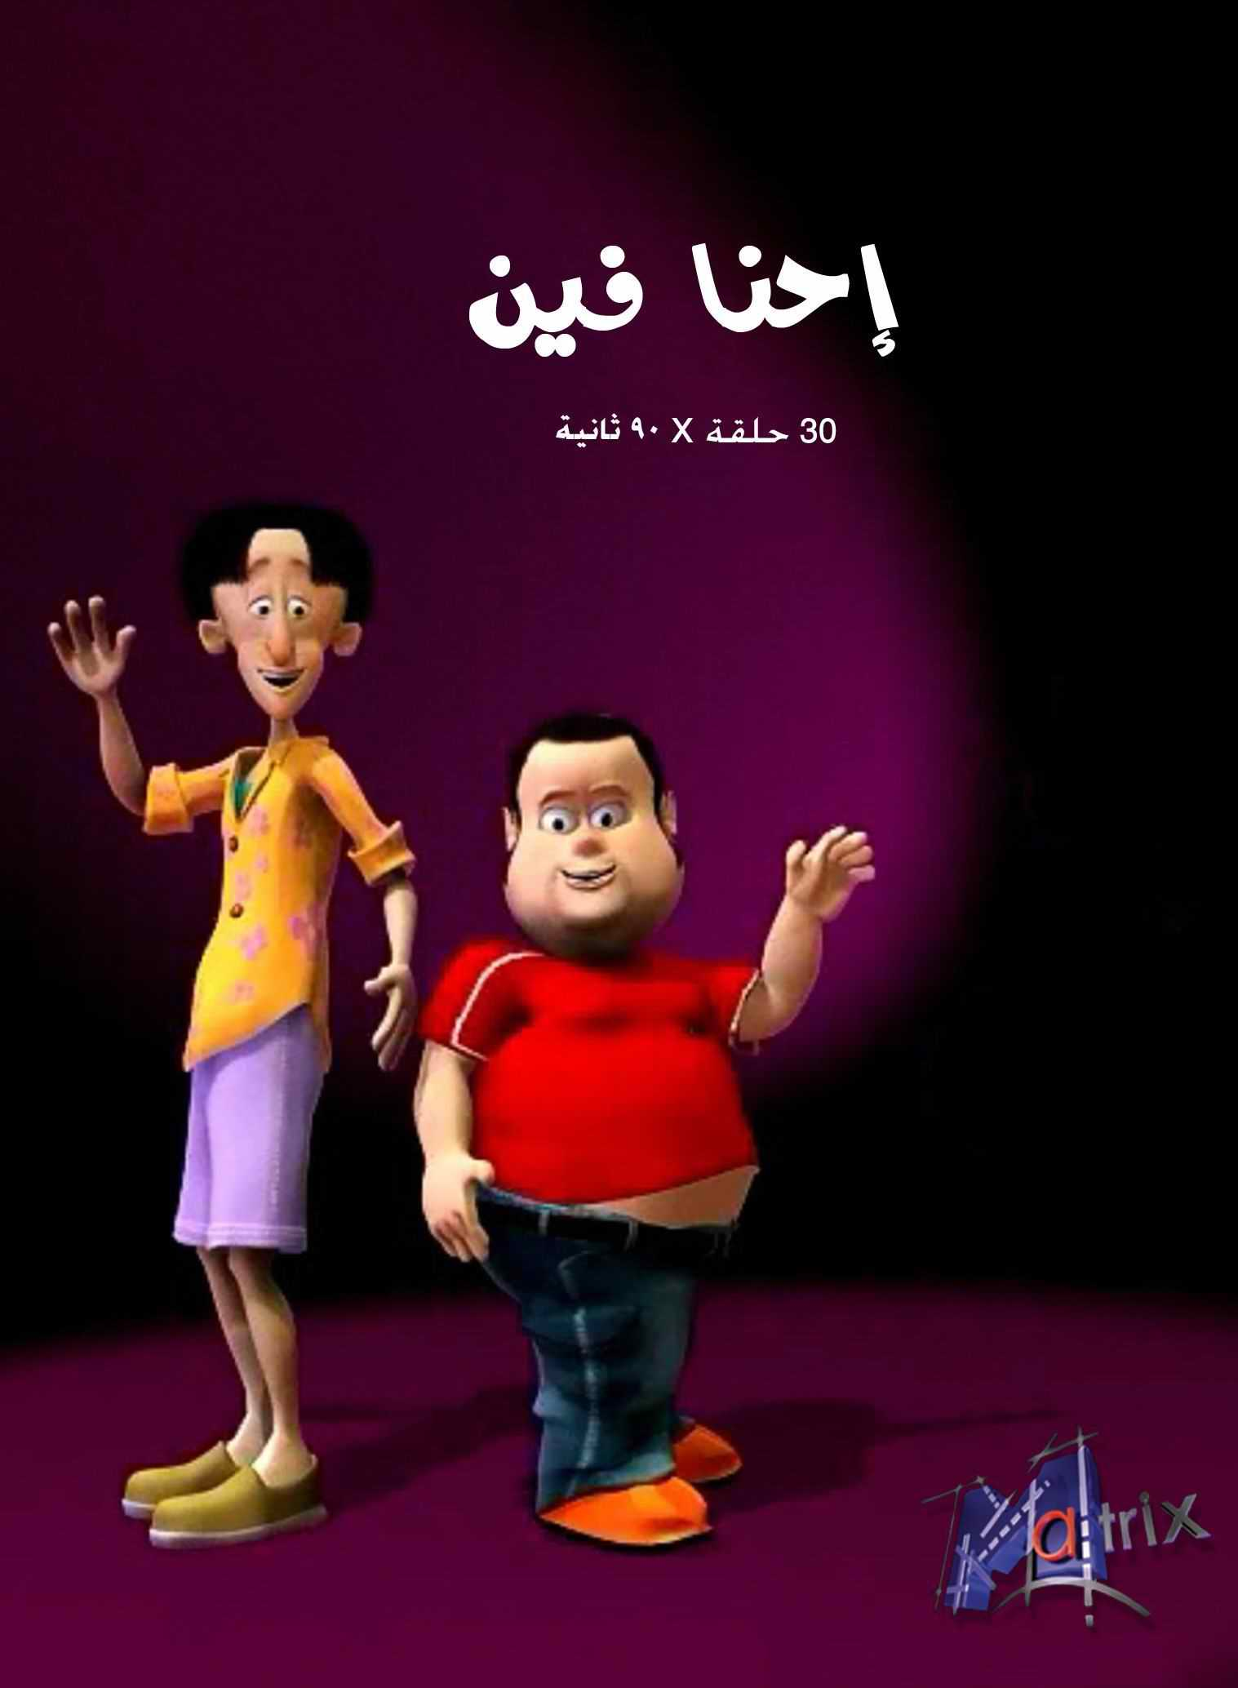
Overview:
The stars: "Mokbil" and "Lamiee", they're 2 youths in the age of 20; wearing their modern cloths, acting in a very funny way.
The Idea of the program: In each episode, "Mokbil" & "Lamiee" travel to a new country where we can see with them the most famous sights in this country, that's through a funny adventure they may face.

Names of countries:
16 - Germany | 1 - China
17 - Japan | 2 - Mexico
18 - Sri Lanka | 3 - India
19 - Zaire | 4 - Greece
20 - Tunis | 5 - Italy
21 - Switzerland | 6 - Kuwait
22 - Spain | 7 - Jordan
23 - Scotland | 8 - Eskimo
24 - Lebanon | 9 - Netherlands
25 - Congo | 10 - Turkey
26 - Saudi Arabia | 11 - Denmark
27 - Romania | 12 - Australia
28 - Brazil | 13 - England
29 - United States of America | 14 - France
30 - Egypt | 15 - United Arab Emirates

Sample Episodes:
For samples screening; visit our website (egymatrix.com) or use the following links:
- Where are we – Ep: China:
http://youtu.be/BTaHQD4qYBE
- Where are we – Ep: Egypt:
http://youtu.be/OEeYf7Bq7IE

